CLOUD COMPUTING

INTRODUCTION….

IT IS A ON DEMAND AVAIBLITY OF COMPUTER SYSTEM RESOURCES, ESPECIALLY DATA STORAGE (CLOUD STORAGE) AND COMPUTING POWER WITHOUT DIRECT ACTIVE MANAGEMENT BY THE USER.THE TERM IS GENERALLY USED TO DESCRIBE DATA CENTRES AVAILABLE TO MANY USERS OVER THE INTERNET.
CLOUD COMPUTING IS AN APPLICATION BASED SOFTWARE INFRASTRUCTURE THAT STORES DATA ON REMOTE SERVER , WHICH CAN BE ACCESED THROUGH THE INTERNET . THE FRONT END ENABLES A USER TO ACCESS DATA STORED IN A CLOUD USING AN INTERNET BROWSER..

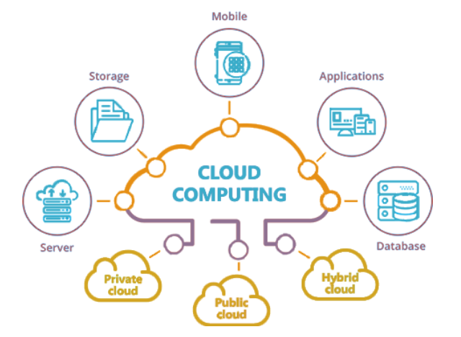

Figure 1

- CLASSIFICATION OF CLOUD COMPUTING

CLOUD COMPUTING HAS MANY TYPES…
1.2.1 PUBLIC CLOUD
Public cloud are cloud environments typically created from IT infrastructure not owned by the end user. Some of the largest public cloud providers include Alibaba Cloud, Amazon Web Services (AWS), Google Cloud, IBM Cloud, and Microsoft Azure.
Traditional public clouds always ran off-premises, but today's public cloud providers have started offering cloud services on clients’ on-premise data centers. This has made location and ownership distinctions obsolete.

    - PRIVATE CLOUD
Private clouds are loosely defined as cloud environments solely dedicated to a single end user or group, where the environment usually runs behind that user or group's firewall. All clouds become private clouds when the underlying IT infrastructure is dedicated to a single customer with completely isolated access.
But private clouds no longer have to be sourced from on-prem IT infrastructure. Organizations are now building private clouds on rented, vendor-owned data centers located off-premises, which makes any location and ownership rules obsolete. This has also led to a number of private cloud subtypes, including

1.2.3 HYBRID CLOUD
A Hybrid cloud is a seemingly single IT environment created from multiple environments connected through local area networks (LANs), wide area networks (WANs), virtual private networks (VPNs), and/or APIs.
The characteristics of hybrid clouds are complex and the requirements can differ, depending on whom you ask. For example, a hybrid cloud may need to include:
- At least 1 private cloud and at least 1 public cloud
- 2 or more private clouds
- 2 or more public clouds
- A bare-metal or virtual environment connected to at least 1 public cloud or private cloud

Types Of Cloud Services

  - iaas(infrastructure as a service)
Infrastructure as a Service (IaaS) contains the most basic building blocks for Cloud infrastructure and offers services on tops of it such as renting IT infrastructure (virtual or physical) and networking features.
2.PaaS(platform as a services)
Platform-as-a-service (PaaS) refers to the supply of on-demand tools for developing, testing, delivering, and managing software applications.
3.SaaS(SOFTWARE AS A SERVICE)
Software-as-a-service (SaaS) is a method for delivering on-demand software applications through Cloud on a subscription basis. A CSP takes care of managing the Cloud infrastructure and offers SaaS applications over the internet to a user that are accessible through a web browser.
4.FaaS(FUNCTION AS A SERVICES)
Functions as a Service (FaaS) adds another layer of abstraction to PaaS so that developers are completely isolated from everything in the stack below their code. FaaS is the concept of Serverless Computing. Instead of handling the hassles of virtual servers, containers, and application runtimes, they upload narrowly functional blocks of code and set them to be triggered by a certain event. FaaS applications consume no IaaS resources until an event occurs, reducing pay-per-use fees.



USES OF CLOUD COMPUTING
File storage: You can store all types of information in the cloud, including files and email. This means you can access these things from any computer or mobile device with an Internet connection, not just your home computer. dropbox and Google are some of the most popular cloud-based storage services.
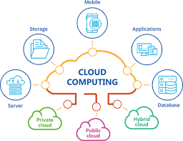
Figure 2: USES OF CLOUD COMPUTING
File sharing: The cloud makes it easy to share files with several people at the same time. For example, you could upload several photos to a cloud-based photo service like Flickr or iCloud Photos, then quickly share them with friends and family.
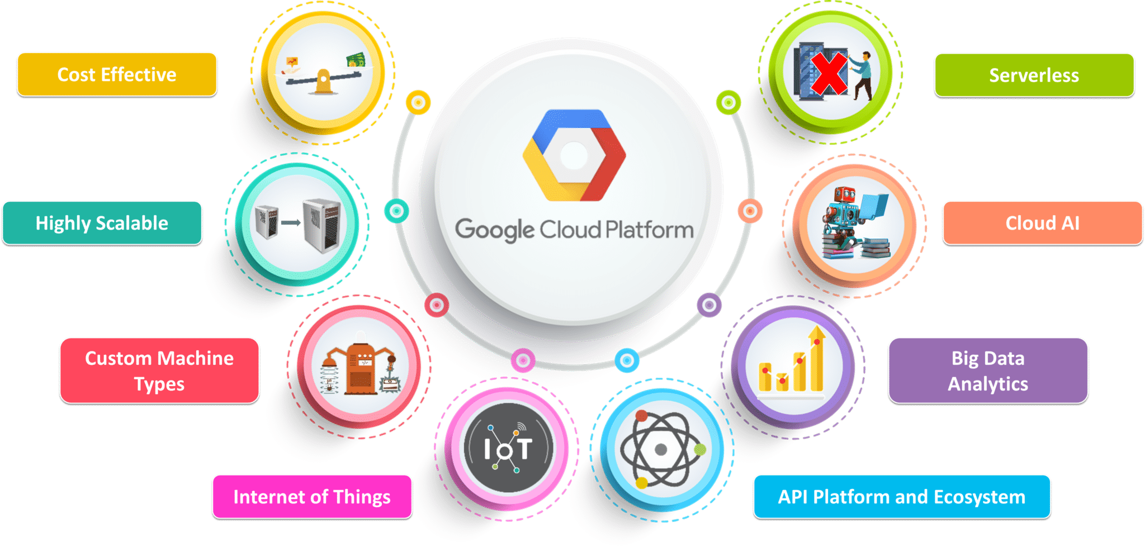

Figure 3: GOOGLE CLOUD

VENDORS OF CLOUD COMPUTING
4.1 AMAZON WEB SERVICES
Amazon Web Services, Inc. (AWS) is a subsidiary of Amazon providing on-demand cloud computing platforms and APIs to individuals, companies, and governments, on a metered pay-as-you-go basis. These cloud computing web services provide a variety of basic abstract technical infrastructure and distributed computing building blocks and tools. One of these services is Amazon Elastic Compute Cloud which allows users to have at their disposal a virtual cluster of computers, available all the time, through the Internet.
4.2 GOOGLE CLOUD SERVICES
Google Cloud Platform (GCP), offered by Google, is a suite of cloud computing services that runs on the same infrastructure that Google uses internally for its end-user products, such as Google Search, Gmail, Google Drive, and YouTube Alongside a set of management tools, it provides a series of modular cloud services including computing, data storage, data analytics and machine learning. Registration requires a credit card or bank account details.^{[5]}
Google Cloud Platform provides infrastructure as a service, platform as a service, and serverless computing environments.

4.3 MICROSOFT AZURE
Microsoft Azure, commonly referred to as Azure is a cloud computing service created by Microsoft for building, testing, deploying, and managing applications and services through Microsoft-managed data centers. It provides software as a service (Saas), platform as a service (PaaS) and infrastructure as a service (IaaS) and supports many different programming languages, tools, and frameworks, including both Microsoft-specific and third-party software and systems.
4.4 DROPBOX
Dropbox is a file hosting service operated by the American company Dropbox, Inc., headquartered in San Francisco, California, that offers cloud storage, file synchronization, personal cloud, and client software. Dropbox was founded in 2007 by MIT students Drew Houston and Arash Ferdowsi as a startup company, with initial funding from seed accelerator Y Combinator.
Dropbox has been ranked as one of the most valuable startups in the US and the world, with a valuation of over US$10 billion, and it has been described as one of Y Combinator's most successful investments to date. However, Dropbox has also experienced criticism and generated controversy for issues including security breaches and privacy concerns.
Dropbox has been blocked in China since 2014. It received a five star rating in the Electronic Frontier Foundation's 2017 "Protecting Your Data From Government Requests" report.



6. Summary and Future Work
Cloud computing is the delivery of computing resources over the internet. It offers cost savings, scalability, high performance, economies of scale, and more. For many companies, a cloud migration is directly related to data and IT modernization.
When the phrase “the cloud” first began popping up in the early 2000s, it had an esoteric ring. The idea of accessing computing resources from somewhere other than an on-premise IT infrastructure (the sky?) sounded like science fiction. The reality was much more profound and forever changed technology and how we conduct business
Before cloud computing, organizations purchased and maintained an on-premise IT infrastructure. Though cost-savings drove much of the initial shift to the cloud, many organizations find that public, private, or a hybrid cloud infrastructure offers a host of benefits.
For agile and DevOps teams, cloud computing provides the ability to simplify and accelerate the development process.
The following is a list of characteristics that define cloud computing.
Cloud infrastructures can grow and shrink dynamically, allowing users to request that their computational resources auto-scale with traffic demands. Elasticity can happen on a per-machine basis, where an allocation of resources grows to maximize the available machine resources, or multi-machine basis, in which an application automatically scales to multi-networked machines.

Cloud infrastructure providers give detailed usage metrics that are used to communicate usage costs. For example, Amazon Web Services (AWS) provides usage for each service category in hourly or daily line items. Cloud service providers generally take a utility style pay-as-you-go billing model that is measured and delivered, so customers are charged for the exact amount of computing resources used

- Cloud computing is the on demand avaiblity of computer system resources, especially data storage (cloud storage) and computing power.
- Cloud computing is an application based software infrastructure that stores data on remote servers.
- Cloud Computing Definition is that it is a shared pool of configurable computing resource (eg. networks, servers, storage, applications, and services) network on demand over the internet.
- Today, Millions of us are happy to use a variety of applications in the cloud, such as applications of CRM, HR, accounting, and even business applications.These applications based in the cloud can be operational in a few days is not possible with traditional enterprise software.
- The advantage of cloud computing is two fold.It is a file backup shape.It also allows working on the same document for several jobs (one person or a nomad traveling) of various types (or PC, tab or smartphone).
- Cloud computing simplifies usage by allowing overcoming the constraints of traditional computer tools (installation and updating of software,storage, data portability…).
- Cloud computing also provides more elasticity and agility because it allows faster access to IT resources (server,storage or bandwidth) via a simple web portal and thus without investing in additional hardware.
- There are three types of computer service-1.IaaS
2. PaaS
3. SaaS
- When it comes to cognitive computing, the term usually refers to AI solutions that replicate the human thought process. Just like the human brain analyses the environment and understands the larger context it operates in, cognitive computing approaches the task of solving problems in the same way
- Types of cloud services- Public cloud , private cloud , hybrid cloud , community cloud….

